My health and wellbeing in prison and beyond 2 (women)

Unit 1
Keeping Clean and Healthy

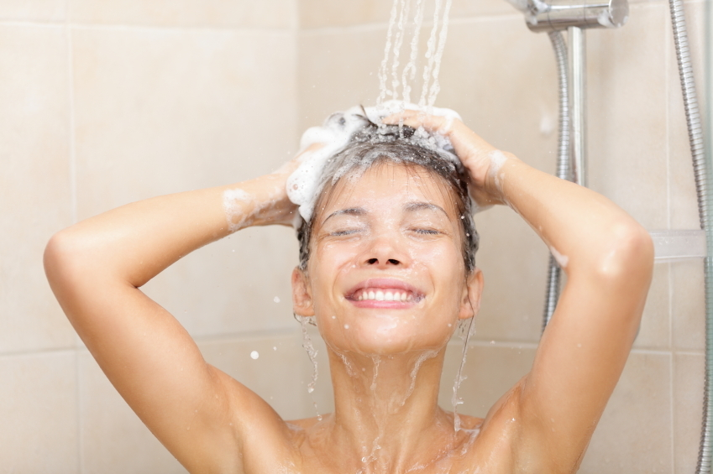

Contents

Unit 1 Keeping clean and healthy: teacher’s notes

Unit 1 Keeping clean and healthy: learner resources

Unit 1 Keeping clean and healthy: answers

Copyright - please read
All the materials on these pages are free for you to download and copy for educational use only in your establishment. You may not redistribute, sell or place these materials on any other website without written permission from the British Council. If you have any questions about the use of these materials please email us at: esolnexus@britishcouncil.org

Unit 1 Keeping Clean and Healthy - teacher’s notes
This resource has been designed for women in prison and supports language development in speaking and listening in the context of health and hygiene. Speaking and listening activities build core vocabulary on personal care that are used to practise reading and writing. It develops knowledge and skills for the practical use of the prison canteen ordering sheet. The session covers elements of personal and social development.

Level: Entry level 1-3 / National 2 – 4 / CEFR A1 - B1

Time: Approximately 90 minutes
Aims
- To build and use essential vocabulary, in spoken and written form, in the context of taking care of your body
- To read and learn to use a prison canteen sheet
- To listen and respond to questions about keeping clean and healthy
- To use expressions of frequency
- To sequence phrases and sentences

Objectives
All learners will be able to:
- Recognise and use some vocabulary on the prison canteen form
- Use essential vocabulary and phrases to make responses to the subject of personal hygiene / healthy habits
Beginners to Entry 2 / National 3 learners will be able to:

- To make spoken statements and ask questions to obtain information
- To use simple phrases to express views and opinions in discussion
- Identify the prefix ‘un’ and words using that prefix

Entry 3 / National 4 learners will be able to:
- To develop writing using a writing frame
- To understand abbreviations used on the canteen sheet
- Identify the prefix ‘un’ and use it to create new words
- Use vocabulary of frequency.

Preparation
You will need:
Your prison canteen list copied for each learner (or copies of resource 3c)
- Resource 1 – one set of cut-up cards per learner
- Resource 2 - one per pair of learners cut into cards 3 and 4
- Resource 3a – 1 per learner
- Resource 3 b - 3 copies for group use
- Resource 3 c - only needed if you cannot access your own prison canteen sheet
- Resource 3 d – I per E3/N4 learner
- Resource 4 a, b and c per learner.
- Resource 5 for E3/N4 extension work one copy per learner
- a collection of empty body care plastic bottles / cans ( eg shampoo, no glass, all aerosols must be empty)
- highlighter pens
- a pencil previously covered in glitter glue for activity 5
- A4 plain paper
- glue stick
- small squirty bottle of bacterial handwash
- crayons / felt pens
- vocabulary books / personal dictionaries

Suggested Procedure
Warmer Essential vocabulary for personal hygiene (10 - 15 minutes)
Whole group activity.
- Give each learner one of the prepared word grids with essential vocabulary from resource 1.
- Elicit meaning and check for understanding. Drill vocabulary with learners at all levels.
- Support pronunciation. Check knowledge and understanding of all words.
- Use one or both of the following games to consolidate vocabulary.
Game 1: Pelmanism
- Learners to work in pairs.
- Each learner to place their cards made from the word grid face down on the table.
- Learners take turns at turning over 2 cards to try and make a matching pair.
- They keep the pairs they find and the player with the most cards wins.
Game 2 Reading activity
- Learners to work in pairs with a set of cards made from the word grid
- Learner 1 displays her cards face up on the table
- Learner 2 reads out each of her cards in turn and learner 1 finds and points to the corresponding.
- Learner 1 to check whether this is correct or not
- Swap roles and repeat.

- Tell learners today’s session will use this vocabulary. Give them time to add words to their vocabulary books / personal dictionaries.
- Ask what they think today’s session might be about, if we are using these words. Responses will help you, as teacher, be aware of the knowledge and vocabulary learners already hold. Accept ideas and praise contributions.
- If they have them, ask learners to record words they are unsure about in their vocabulary books/ personal dictionaries.
Activity 1 Healthy / unhealthy (10 minutes)
- Elicit meaning of ‘healthy’ and ‘unhealthy’ using resource 2. Ask learners to sort the cards into two piles, one set of pictures showing something healthy, the other pile showing something unhealthy.
- Drama activity - ask learners to work in 2 groups, one to form a freeze frame image showing a group of healthy people and the other a group of unhealthy people. Swap over. Encourage them to add sound to the freeze frame if appropriate.
Differentiation for more proficient learners
- To help consolidate understanding of the prefix ‘un’ meaning ‘not’, ask learners to suggest up to 6 more words that use the prefix ‘un’ to mean ‘not’.
- They can use dictionaries for this activity.

Activity 2 Reading and recognising names of products (15 minutes)
- Use the games below to consolidate vocabulary for body care products and familiarise learners with different fonts / capital and lower case words in context.
- Name the product: put a selection of empty body care containers in a carrier or bin bag. To demonstrate the game to learners, pull one item out and ask the learners if they know what it is. Point out the brand name. Pass the bag around the group for each learner to pull out an item in turn, identify the product and then brand name if available.
- Kim’s game: ask a learner to be game leader. Place the empty containers of body care products on a tray on a table where all learners can see. Nominate individuals to name each product. Let them look at the tray for 45 seconds.
- Cover the tray with a cloth and tell the leader to remove one container without anyone seeing what they have removed.
- Reveal the products again and ask learners to identify, which one is missing. Who can write the product name on the whiteboard? Is it spelt correctly? If not, who can help put it right?

Activity 3 Matching (10 minutes)
- Give learners a copy of resource 3a and ask them to draw a line between the product and where you would use it on your body.
- Write the question ‘Where do you use ...........?’ on the whiteboard.
- Write the words shampoo, toothpaste, body wash, face wash, shower gel on the whiteboard
- Encourage spoken feedback by questioning learners about the links between product and body. For example
Where do you use shampoo?
I use shampoo to wash my hair
Where do you use toothpaste?
I use tooth paste to clean my teeth.
- Ask learners to work in pairs and take turns to quiz each other about ‘Where do you use.....?‘ using the nouns on the whiteboard.
- Allow time for learners to work in pairs practising questions and answers. Check understanding of hair care, skin care, body care, tooth care. Check and drill vocabulary from the hand out. Elicit that the products care for different parts of the body.
- Have some fun. Add some questions to help check understanding such as: Do you use body wash on your teeth? Do you use toothpaste on your hair?

Activity 3 Ordering from canteen lists (15 minutes)
- Give each learner a canteen list from the prison you work in or use resource 3c, a typical canteen sheet. Have copies of resource 3b available for photo reference.
- Give learners time to have a look at the section ‘Toiletries and Health’ to see what is available and identify familiar words from the last activities. These items help us care for our bodies. Drill the phrases hair care, skin care, tooth care, body care.
- Beat the Clock - skimming and scanning for detail. Using highlighter pens, ask individual learners to go through and colour code the prison canteen list, or resource 3c, into hair care, body care, face care, tooth care.
- Get learners to check and compare answers with each other. What was different between any lists? Listen and check their answers as you move around the class.

Extension activity for E3/N4 learners
- Abbreviations – the list frequently abbreviates items. This can be confusing and difficult for some learners. Examples are: T/paste = toothpaste; Cond = conditioner; shamp = shampoo. Ask E3 learners to identify the abbreviations and complete the following activity.
- Distribute resource 3d, template cards. Ask the learners to make matching game by writing the unabbreviated word in a box and the abbreviation (shortened word) in another. Find as many abbreviations as possible in the toiletries section and make a series of cards showing the full words and abbreviations.
- Ask them to work with lower level learners to match the abbreviations and full words.
- Advanced vocabulary: Ask learners to highlight more complex vocabulary on the canteen list they don’t know, for example, whitening.
- Write these on the board and invite suggestions for what they are. Support learners to look them up in dictionaries and add them to their vocabulary book / personal dictionary.

Activity 4 What can you buy in prison to stay clean and healthy? (15 minutes)
This gives practice at more detailed reading of the canteen sheet and making an order from the sheet.
- Resources 4a, 4b and 4c are graded. Match suitable level to your learners and distribute accordingly.
- Ask learners to refer to the ‘toiletries and health section in the canteen list.
- Tell learners to choose some products to help keep their bodies clean and healthy.
- Fill in resource 4 with their choice of body care items, price and code.
Differentiation
- Beginner to E1 / N2– learners can tick choices directly on the canteen list and copy their selection into exercise books.
- Entry 2 – ask learners to choose products from the canteen list and copy product name in the boxes on Resource 4b
- Entry 3 – learners to look at the product pictures and write their own lists. Resource 4c allows learners to select and list their own choice of products working individually.
- As you move around the class ask what they have chosen and why.
Additional activities
- Learners can add up and find total amounts they are spending.
Extension activity
- Give learners a budget to work with.

Activity 5 - Washing your hands (5 minutes)
- Elicit the times when you need to wash your hands. Drill phrases using before and after. For example: after working in the workshop / before preparing food / after playing with a pet /after going to the toilet /after you have a meal
- Elicit why we need to wash our hands, consolidating vocabulary from Activity 1: germs, clean, healthy etc. Pass the glitter pencil you’ve prepared around the class.
- Some of the glitter will come off on each person’s hands. Elicit this is how easily germs are transferred and washing can keep us safe from germs. Use the squirty hand wash to clean the glitter off.

Activity 6 - listening and responding using language of frequency.(10 minutes)
- Write up the following expressions of frequency on the whiteboard: every day, twice a day, three times a week, every week, every month.
- Ask learners to order the words / phrases from the most frequent to the least frequent.
- Using words in resource 5 working in small groups, ask learners to shuffle the cards and make 2 piles one with language of frequency words and one with ‘keeping clean’ actions.
- Take turns to pick a card from each pile and say a sentence using the two words on their cards. Other members of the group to decide whether this is good or bad statement about keeping clean and healthy.

Extension activity for Entry 3
- Write an information sheet for new prisoners who need to know how to keep clean and healthy in prison
- Support this with question prompts – put some / all of these on the whiteboard:
When can you have a shower? Every day? Twice a week? Where can you have a shower? What time can I have a shower? Can I wash in my cell? When can I get my clothes washed? Can I go to the laundry? How many things can I send to the laundry?
- Build more questions of your own to suit your prison context.

Cooler
- Revisit resources 3a, b or c and ask each learner in turn to tell the rest of the group one thing they chose to put in their wash bag to allow all learners to have a chance to speak at the end of the session.
Unit 4 Taking care of our bodies - additional resources for teachers
Resource 1
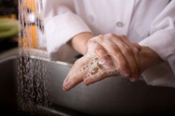  clean |   dirty | 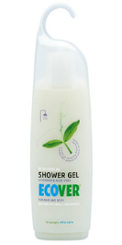  shower gel
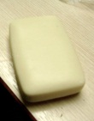  soap | 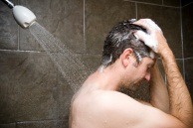  wash | unhealthy 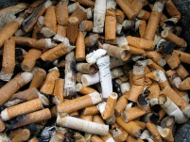
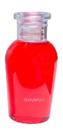  shampoo | 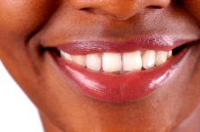  teeth |   toothpaste
  healthy | 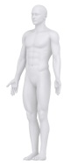  body | germs 

  clean |   dirty |   shower gel
  soap |   wash | unhealthy 
  shampoo |   teeth |   toothpaste
  healthy |   body | germs 

Resource 2 Sort these cards into healthy or unhealthy:

 | 
 | 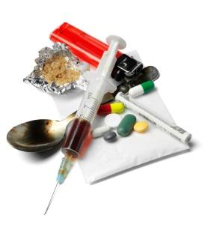
 | 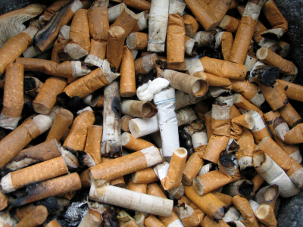
 | 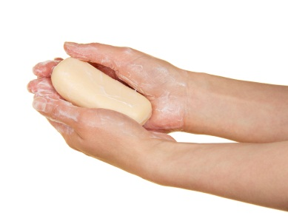

Resource 3a
Taking care of your body
Draw a line from each product to the part of the body where you would use it.


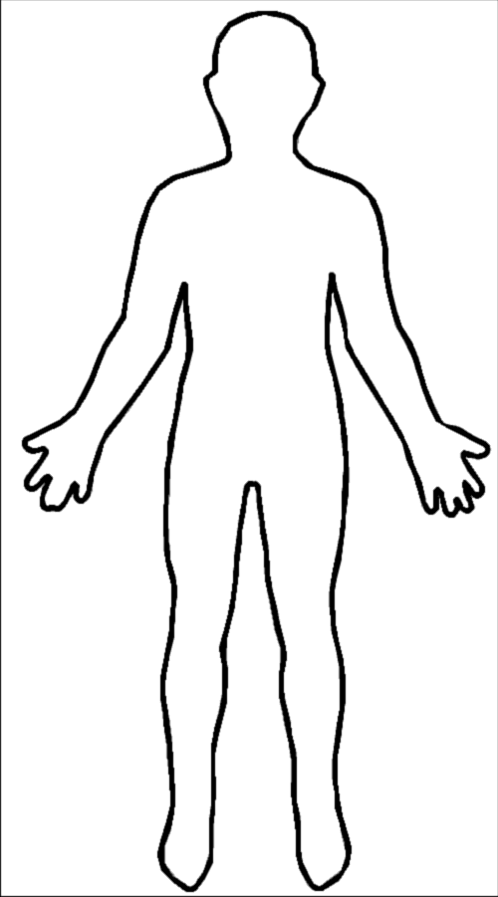
toothbrush

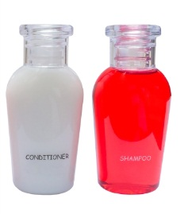
 toothpaste

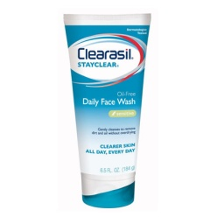
shampoo and conditioner

face wash
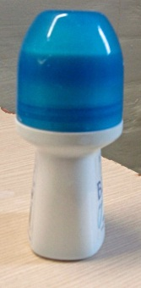
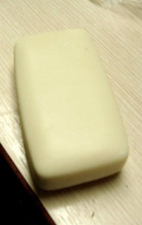

soap

deodorant

–

Resource 3b Toiletries – what can you see?

Image of toiletries

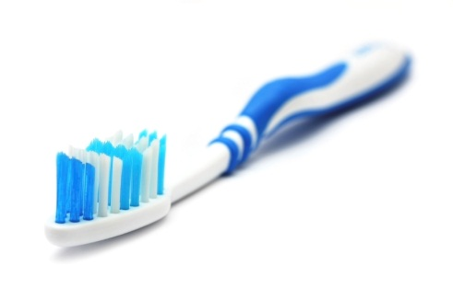


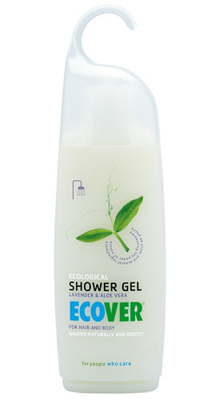

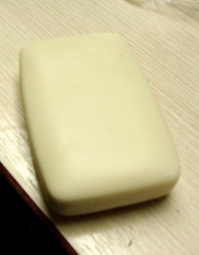

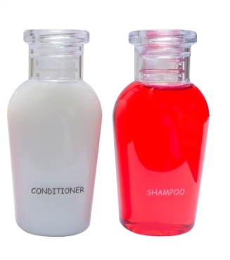
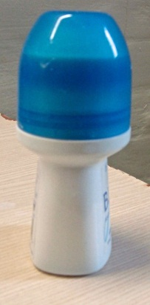

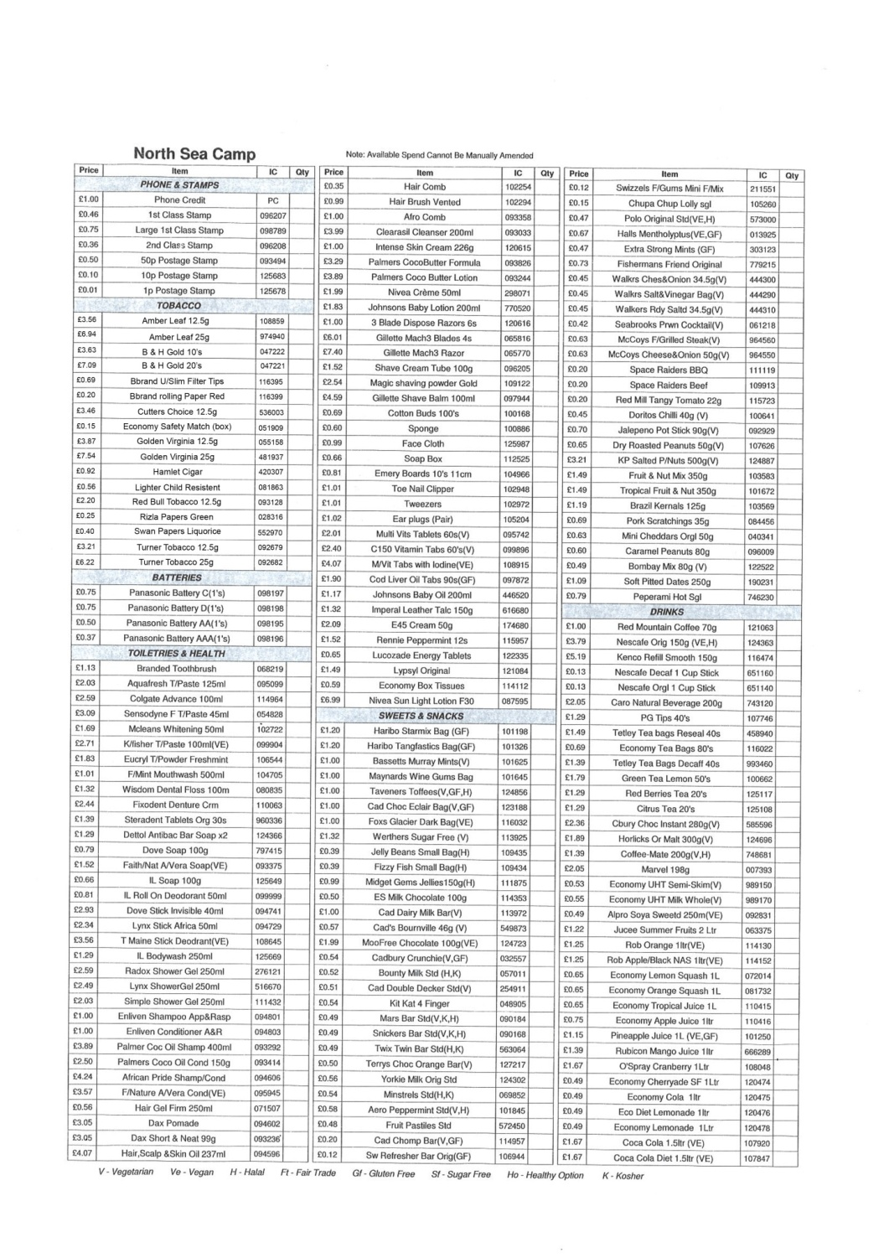

Resource 3c Canteen sheet
Resource 3d
Make a matching card game with abbreviations and full words from the canteen sheet

Resource 4a What can I buy? Tooth care? Body care? Hair care?
Look at the canteen sheet and choose 6 things to buy. Copy the product code carefully. Add the price of your product.
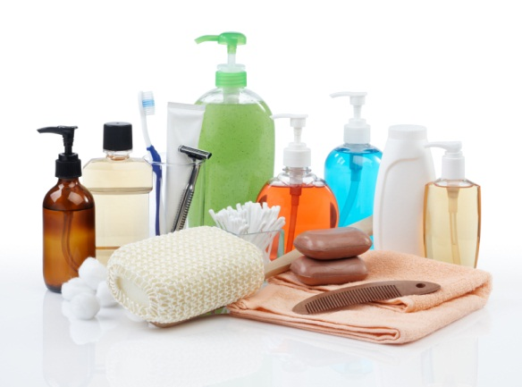
I can buy ...................  Product code:  Price: £ | I can buy...................  Product code:  Price: £
I can buy .......................  Product code:  Price: £ | I can buy...................  Product code:  Price: £
I can buy...................  Product code:  Price: £ | I can buy...................  Product code:  Price: £
a

Resource 4b Look at the canteen sheet. Find a product for each line. Write the product code and price of each product.
Product | Product code (PC) | Price
deodorant |  | £
moisturiser |  | £
mouthwash |  | £
shampoo |  | £
soap |  | £
toothpaste



Resource 4c My body care products


Choose 6 things you would like to buy. Fill in the boxes. Ask the person next to you to check the form is right.
Product | Product code | Price
 |  | £
 |  | £
 |  | £
 |  | £
 |  | £
 |  | £

Resource 5 How often

Every day | I clean my teeth
Twice a day | I wash my hands
Three times a week | I have a shower
Every week | I wash my hair
Every morning | I wash my face

